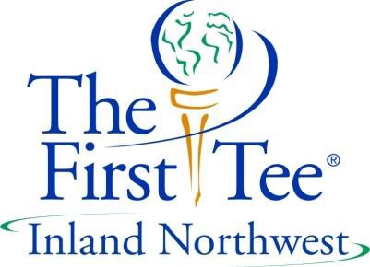
Head Coach Responsibilities - 2017

Primary Function
The Head coach is responsible for guiding and coaching young people to become responsible citizens and committed active golfers. Positively impacting their lives through The First Tee Golf & Life Skills Experience using approved lesson plans and The First Tee Coaching Philosophy.

Key Roles
- Has overall responsibility for all on-course The First Tee activities
- Guide the Team Leaders in that week’s golf activities
- When needed, serve role as Team Leader to facilitate that week’s golf activities
- Be a positive role model for youth by reinforcing the First Tee Nine Core Values and adhering to The First Tee Code of Conduct
- Convey The First Tee brand image to the public
- Assist Director of Golf with development of new procedure and programs to improve registrations, retention, and progression
- Encourage and assist qualified youth to participate in Home Office Participant Opportunities
- Provide a fun and safe youth environment in all areas
- Assist in recruiting and retaining volunteers in green grass initiatives
- Assist with Parent Orientations and maintain open parent/student communication
- Network with other chapter colleagues and exchange best practice ideas

Expectations
- Complete ACT online training and be willing to attend coach training, working toward Recognition status
- Maintain consistent and regular attendance – student and volunteer
- Input league score data in a timely manner
- Weekly notify office staff of any Head Coach assignment changes
- Have some golf skill knowledge; able to analyze/fix minor swing flaws (Posture, Grip, Alignment).
- Ensure station setups are detailed and consistent with lesson plan objectives
- Maintain lesson plan integrity at all classes and levels
- Conduct pre-lesson instruction sessions with class volunteers
- Create and submit new activity ideas for lesson plan implementation
- Conduct Certifications at all levels
- Maintain and organize all equipment and storage areas
- Provide students and families with updated progress reports at the end of every session
- Respond to all info, data, and report requests in a timely manner.
- Attend meetings, roundtables and training sessions conducted by Director of Golf
- Conduct good-better-how sessions with volunteers
- Attend Community Outreach events (i.e., golf show, river park square, Summer Parkways, etc.)

